The Escape from Klvaň's high school
Klvaň Gymnasium and Kyjov Secondary Medical School,
funded organisation
třída Komenského 549/23, 697 01 Kyjov
Contents:
Project information 3
Project objectives 3
Microphone 5
Tripod 6
Stabiliser 7
Micro:bit 9
Component 9
3D Printer 13
Preparatory phase of the project 15
3D printing workshop 15
Micro:bit 17
Online forms 20
Escape game 21
Diagram 21
Cellar 22
Biological laboratory 24
Physics laboratory 26
History classroom 27
Geography classroom 28
Chemistry classroom 28
The End 30
Operation of escape hatch 31
Making the escape route available to the public 31
Limiting the number of solutions 32
Conclusion 33

Project information
The Escapee from Klvaň's high school project was aimed at strengthening the technical and digital skills of lower gymnasium students. Using the validity of the good old laws of physics in combination with modern technologies, the students created an interesting escape game that will interest current high school students as well as those interested in future studies at our school.

Project objectives
- Pupils will create a digital escape game behind the scenes of the Klvaň Gymnasium using camera recordings of physics experiments and robotic tasks.
- Pupils design individual physics experiments and robotic tasks.
- Pupils carry out the planned activities and record them on a digital camera.
- Pupils cut short video clips from the recorded material for use in a digital escape game.
- Pupils will create a website with an escape game.
- Pupils will prepare promotional materials (presentations, leaflets) for their creation.

Material equipment needed to implement the project
Digital camera
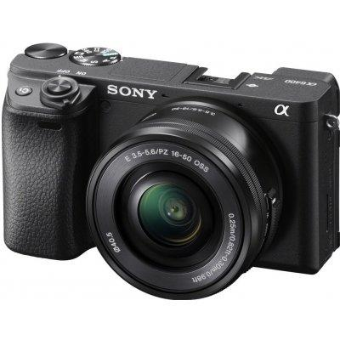
https://www.megapixel.cz/sony-alpha-a6400-16-50-mm-cerny-foto-kit/
The camera used was a Sony Alpha 6400 digital camera. Despite its small size, it can do big things, such as shooting videos in 4k quality and 30 fps. It also handles photos perfectly, thanks to the 24.2 Mpx resolution of the camera. When filming the experiments, we put the camera on a tripod, thanks to which it was fixed in a certain position that we could choose ourselves. We put the camera with a tripod on a stand, which made it easier for us to handle the camera. So that you can hear us well while filming, we connected an external microphone to the camera via USB for the complete perfection of our videos.
This camera has a large battery, so we had no problem recording for three hours at a time, and it is also very easy to use, so the work fell away by itself. Even after filming more than fifteen attempts, our storage was half empty.

Microphone
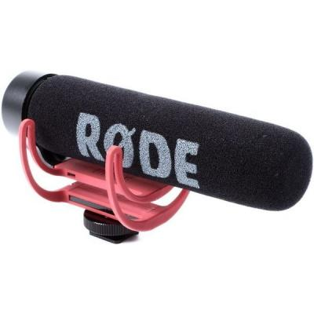
https://www.megapixel.cz/rode-mikrofon-videomic-go/
VideoMic GO made our work a lot easier, the sound was sharp and didn't chop, it was really easy to work with. VideoMic GO delivers incredibly clear and crisp directional sound. The narrow sensing angle is concentrated directly in front of the microphone, thereby limiting the penetration of unwanted ambient noise into the recording. In this way, the sound of the recorded object comes to the forefront of the recording. The microphone is made from one piece of durable thermoplastic. VideoMic GO has no complicated switches, nor does it need to be set up. It does not need any battery for its operation. Working with the microphone was simple and we all enjoyed it.

Tripod
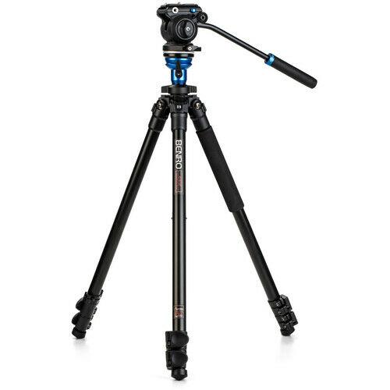
https://www.megapixel.cz/benro-a1573fs2-videohlava-s2/
The Benro A1573 tripod with the S2 svideo head helped us a lot in filming physical experiments. It is easily portable and also requires precision, stability and fluidity of every shot.
Benro A1573F is a three-section aluminium tripod + ultra-light S2 video head with smooth movement, QR4 quick-release plate. The head allows a tilt in the range of +85 / -85. The load capacity of the tripod is 2.5 kg, which is given by the effective balance of the tripod head for smooth movement of the camera or camera. The integrated level makes it easy to align with the horizon.

Stabiliser
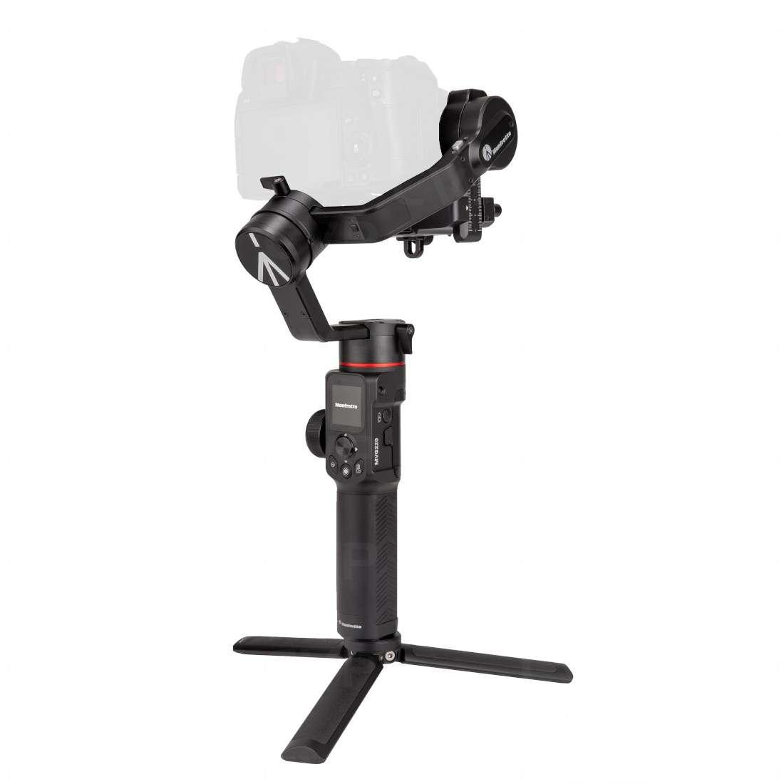
https://www.megapixel.cz/manfrotto-gimbal-220-kit/
The Manfrotto MVG220 is a professional gimbal that takes care of video stabilisation when shooting handheld in 3 axes. The gimbal is designed for mirrorless and DSLR cameras. It is designed for dynamic scanning and can handle devices weighing up to 2.2 kg. It is the ideal choice for photographers, videographers, vloggers and bloggers looking for a versatile device with different modes for maximum flexibility.
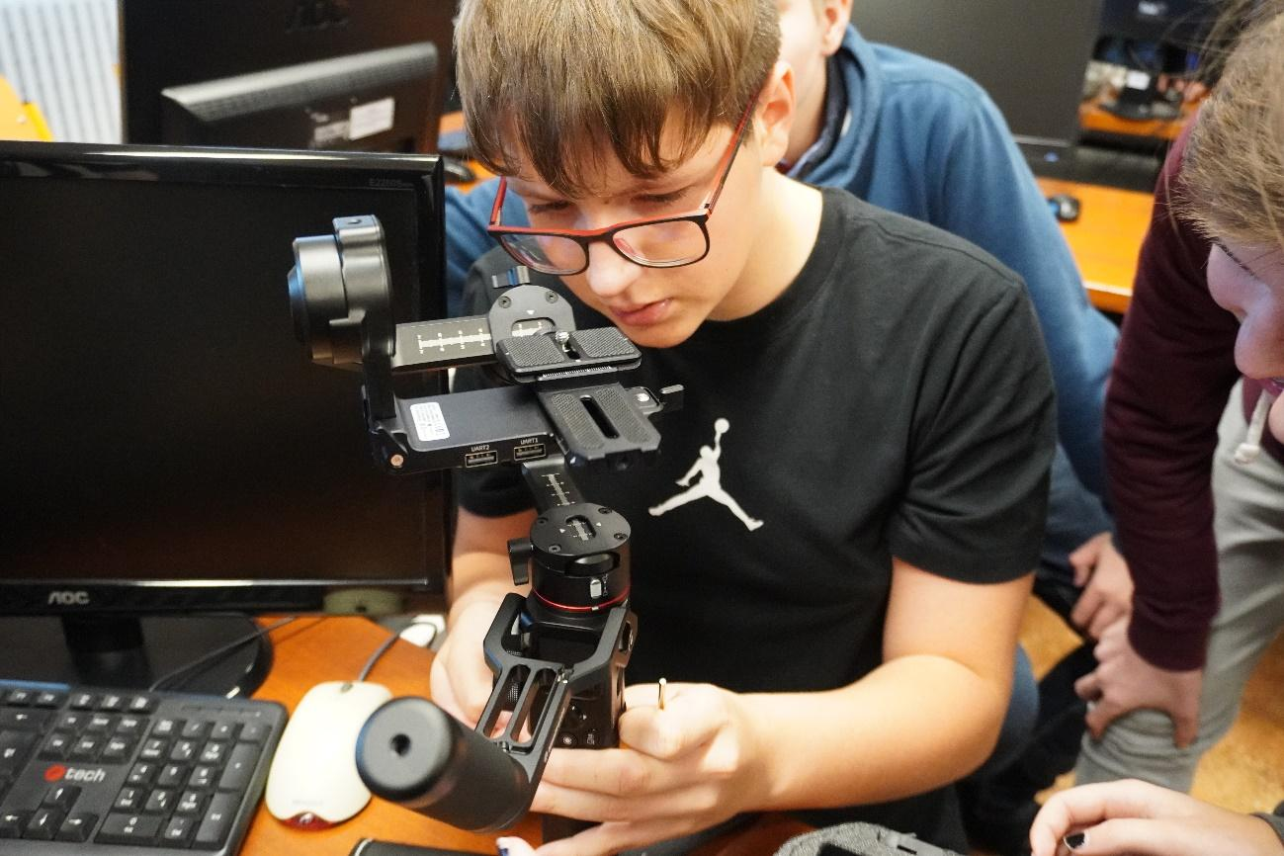
We tried to assemble the image stabiliser according to the instructions that were included in the package with the components for assembling the stabiliser. The more capable ones grabbed it and tried to figure out which piece belonged to which. Since the design of the stabiliser was complex, we were not very successful and in the end we gave up trying without success and left this difficult task to our professor. However, we took away an interesting and instructive experience.

Micro:bit
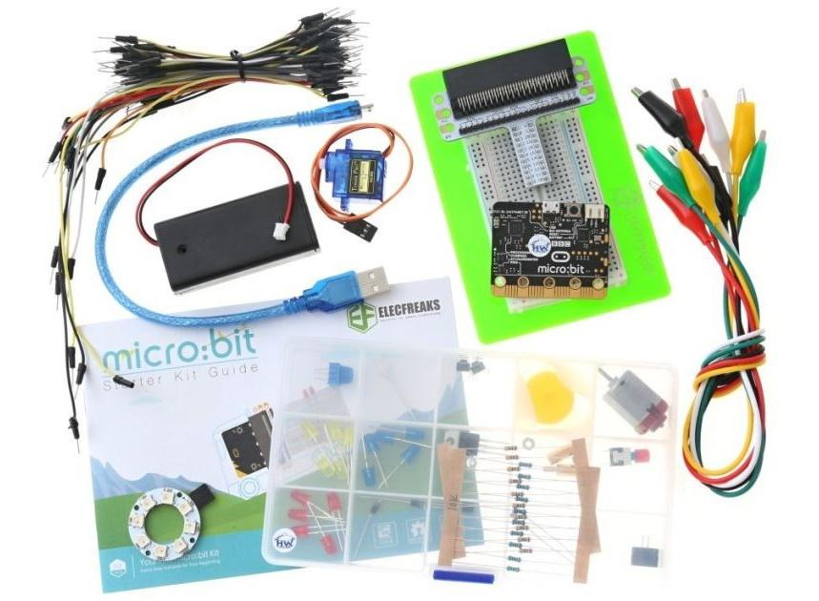
https://www.hwkitchen.cz/bbc-microbit-starter-kit/
During the preparations for the escape game, we tried working with the micro:bit. Micro:bit is suitable for those who are just about to open the door to the world of electronic circuits and programming knowledge. The Starter Kit contains over 20 basic electronic components. After assembling the mechanical part, it is important to correctly program the micro:bit so that everything works as it should.

Component:
- 1 × Micro:bit V2 board (included according to kit version)
- 1 × Expansion module for the contact field
- 1 × Battery holder + USB cable (Transparent battery holder 2 × AAA + flexible USB cable 1 m)
- 1 × Contact field 83 × 55 mm (400 connection points)
- 1 × EF92A micro:servo 180° for micro:bit (1.6 kg / cm)
- 1 × Digital temperature sensor TMP36
- 1 × Light sensor
- 65 × Connecting wire M/M (4 different lengths)
- 1 x RGB LED ∅5 mm
- 5 x Red LED ∅5 mm
- 5 × Blue LED ∅5 mm
- 5 × Yellow LED ∅5 mm
- 5 x Green LED ∅5 mm
- 1 × Potentiometer 10 kΩ
- 2 × Button
- 1 × Switch
- 1 x Buzzer
- 10 × Resistor 100 Ω
- 10 × Resistor 10 kΩ
- 5 × Connection cable with alligator clips
- 1 x 5 V motor with fan
- 1 × TIP120 Power Transistor (NPN)
- 2 x Diode 1N4007
- 1 x 8 RGB LED rainbow ring
- 1 × Parts box (15 compartments)
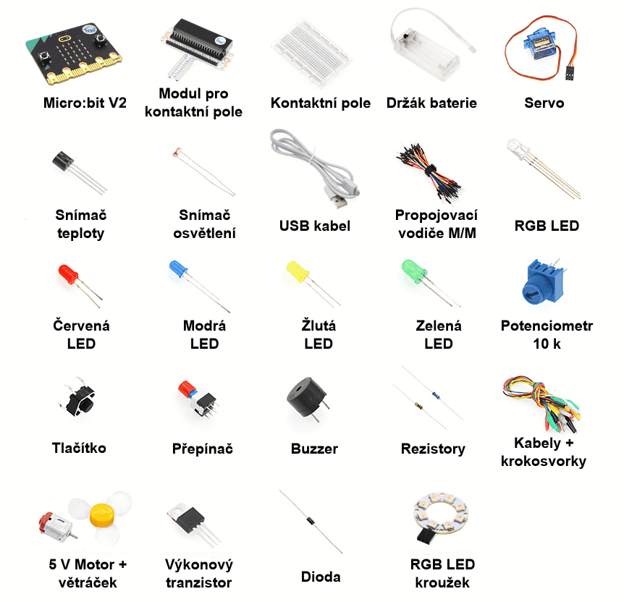
Micro:bit V2, Module for contact field, Contact field, Battery holder, Servo drive
Temperature reader, Light reader, USB cabel, conecting wires M/M, RGB LED
Red LED, Blue LED, Yellow LED, Green LED, Potenciometer 10k
Button, Switch, Buzzer, Resistors, wires and clips
5 V engine and fan, performance transistor, Diode, RGB LED cirlce
Along with these components, the micro:bit also includes a colourful instruction manual with various tasks. Each page has instructions for both the mechanical part and the program.
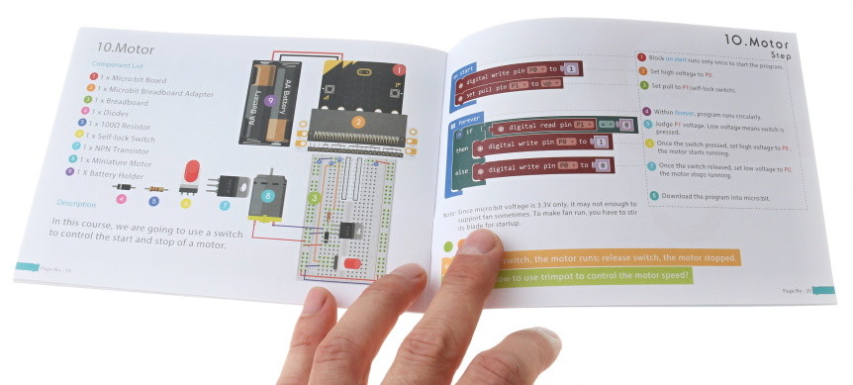
In addition to this Starter Kit, we had two other types of kits available, but in the end we didn't get around to testing them.

3D Printer
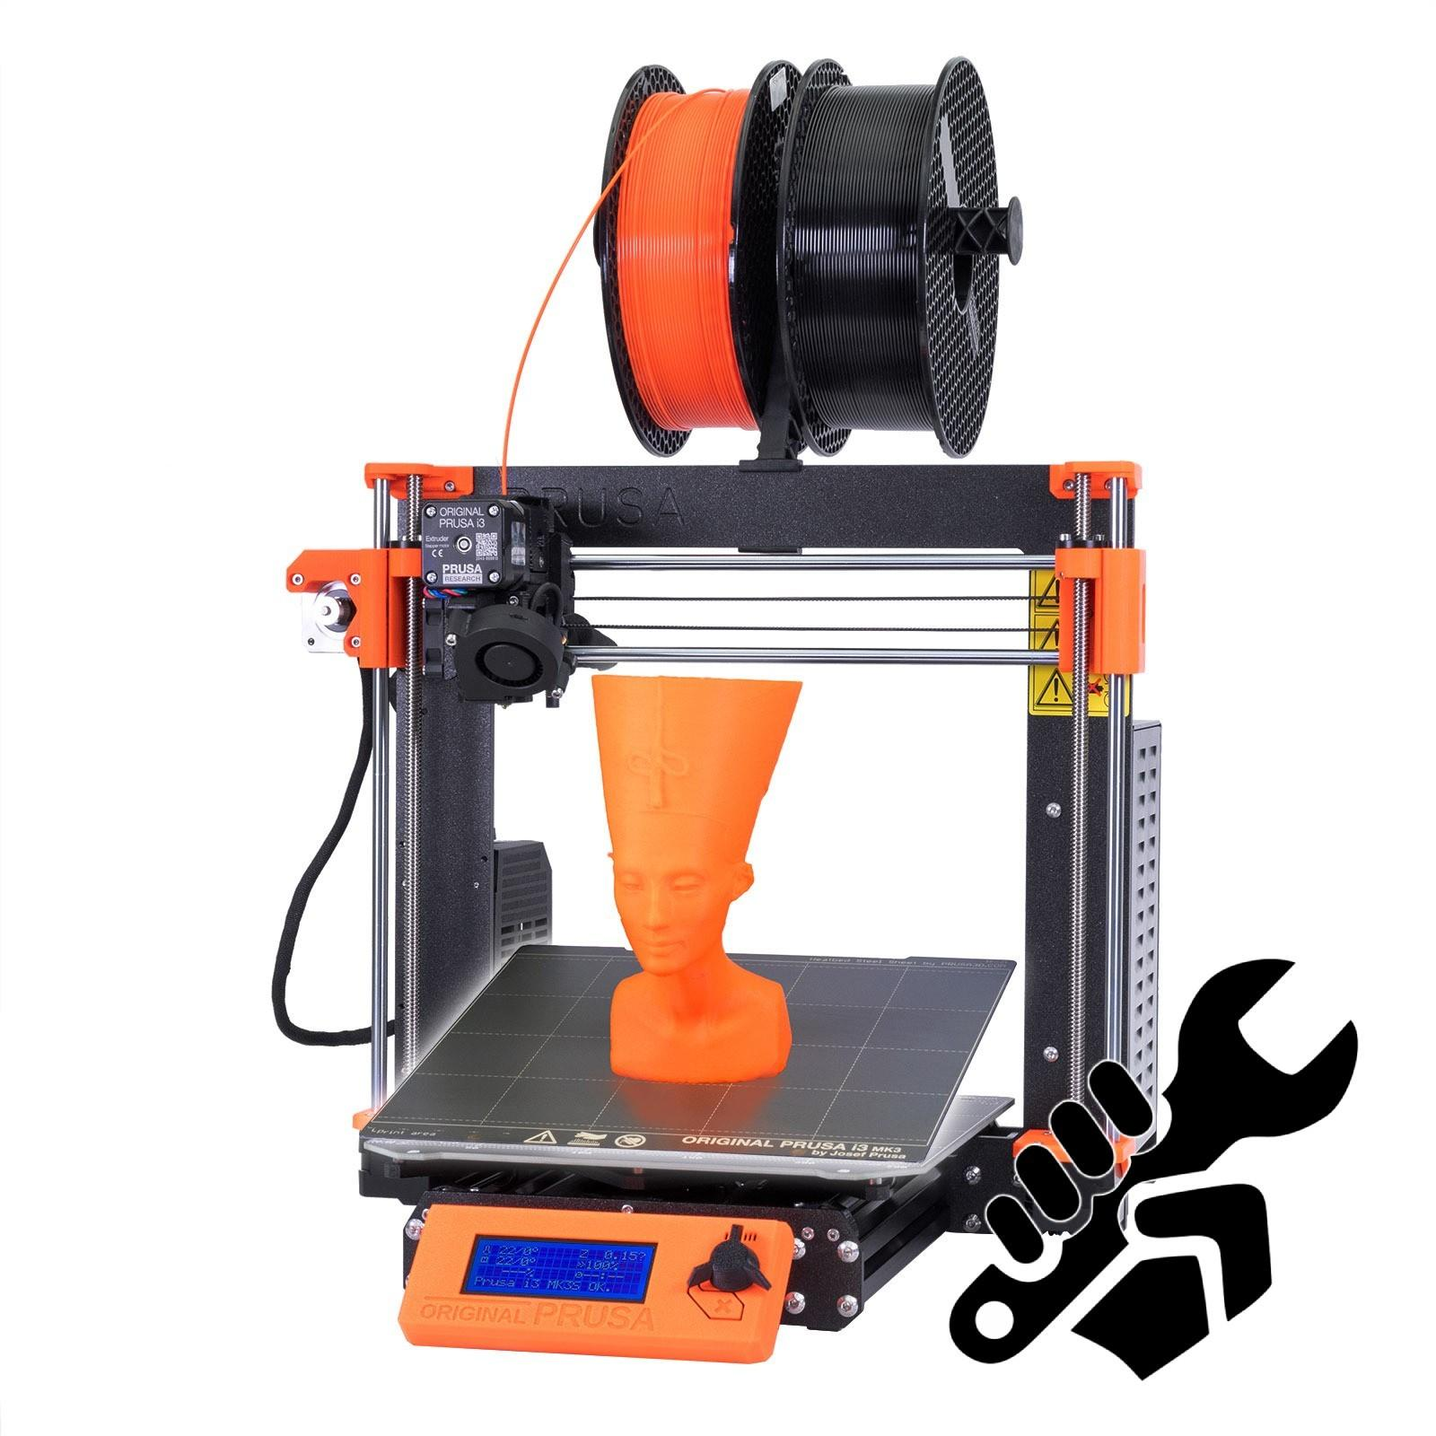
https://www.prusa3d.com/cs/produkt/stavebnice-3d-tiskarny-original-prusa-i3-mk3s-3/
Our school had the opportunity to purchase new 3D printers, specifically the i3 MK3S+ model from PRUSA RESEARCH by Josef Průš. The printer is able to print its own key components, and it's also open source hardware, which means that there are a number of unofficial variants in addition to its basic form. The relatively low price, easy assembly and modification made it popular both in the world of enthusiasts and professionals. Above all, it is also used for educational purposes abroad. The company was founded in 2012 by Josef Průša, a Czech handyman, inventor and investor – and now he is one of the most famous people in the field of 3D printing. The beginnings were very modest, no investors, no campaigns. But Joseph had a plan.

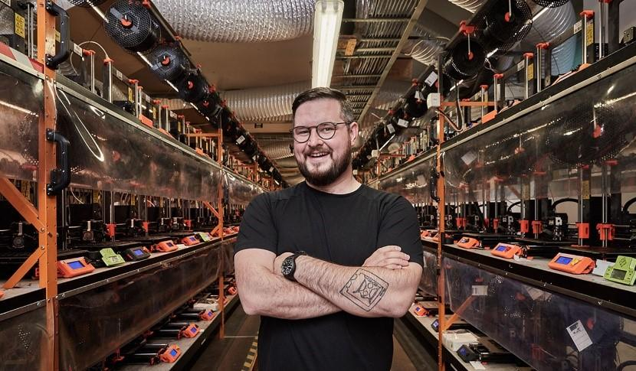
There were only a few shipments a week, but it was still a proper adventure. Currently, over 600 people work in the company and they ship over 9,000 printers worldwide every month. Now the company is located in Holešovíce, where upon entering the building you may feel as if you have entered the garage of some passionate DIYer. Well, this garage consists of eight different floors, where it is tested, invented, improved, experimented... There is no place for boredom here. The company is improving every minute and produces new and new models of printers that will make work easier for the whole world.

Preparatory phase of the project

3D printing workshop
One hour the guys from the Prusa Research project came to us to tell us a bit about what they were doing. For the first hour, they had prepared a beautiful presentation to introduce themselves and the project. They presented the company, 3D printing as such, different types of 3D printers, whether those produced by Prusa Research or their alternatives and predecessors. We learned about the history of the company from its foundation, through moving premises, hiring employees, inventing new models and components, up to what it looks like today. They finally answered all our questions.
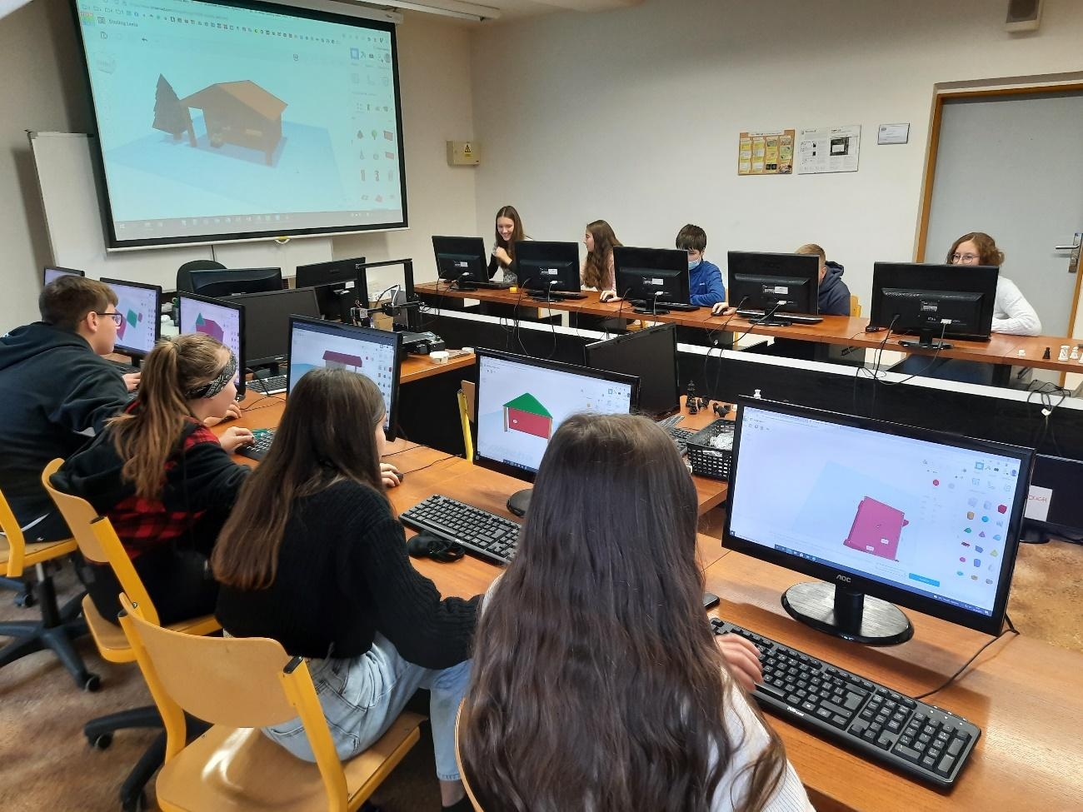
After a short break, we returned to the computer room and this time we could get to work and try 3D printing for ourselves. We visited tinkercad.com, familiarised ourselves with the program and worked in it, and started working. First, we had the task of creating our own name tag for the keys according to the specifications. We placed any shape on the virtual mat in the program, made a hole in it and wrote our names. It took a while, and since we've never worked with anything like this, it took us quite a while (mainly the endless resizing, checking if our text and shape overlap in the base, and endlessly returning the keychain to the pad when we accidentally leaned on the mouse and moved everything) but we didn't give up and in the end we were all happy with the result, the keychains finished and were ready to be printed.

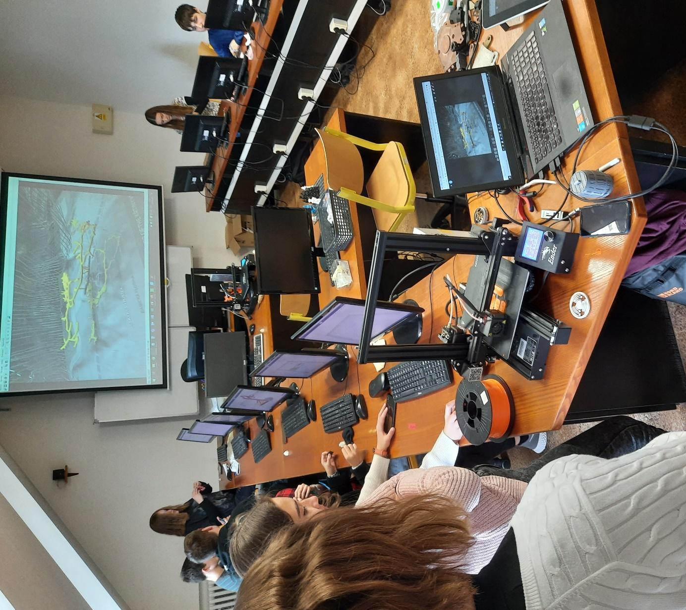
We all breathed a sigh of relief as we put the files into one shared folder and the guys started warming up the printer. However, the workshop did not end there. The next task was to find something in the archive of the program that could help us to teach and prepare for printing. Someone found rulers, someone found a globe, maps... Now we were able to work quite well in the program, so it was a little easier. Those who were done could ask us anything they wanted to know about Prusa Research or 3D printing in general. All questions were answered so we all left with a lot of new knowledge and a handmade keychain.

Micro:bit
We played around with micro:bits for a while before actually creating the escape hatch. This activity develops logical thinking and working with the creation of electrical circuits and subsequent programming of the micro:bit itself.
The first thing we noticed was the seemingly complicated instructions. After a thorough review, we realised what and how to do. We were tasked with using wires and various components to light up three LEDs. At the beginning it seemed impossible, but after we studied the instructions carefully and put the heads together, it was possible. Finally we actually understood how the whole box works. The second part was the program.
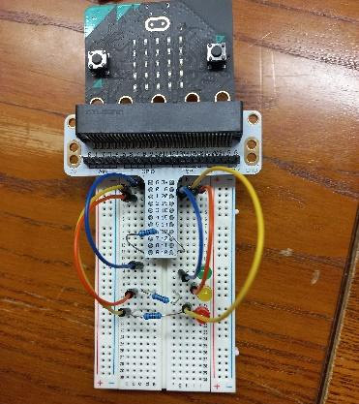
Since the page was nicely done in colour, it wasn't too difficult to figure out how to program the micro:bit. However, the next part was more difficult. We had to download it to the micro:bit, which was also a nice challenge. Because no one knew where or how to download it, it ended up being one of the hardest parts of the whole game. Once we were able to do this, we inserted the micro:bit into the contact patch and using the button turned on all the LEDs. You should have seen our faces because we seriously didn't expect to be able to do something like this, well, it happened. Then we tried other tasks, for example to make them light up intermittently, in some pattern, or more or less thanks to the potentiometer. In the end, we didn't use the micro:bit in the escape book, but we are very happy for this experience and will definitely use it in other projects.

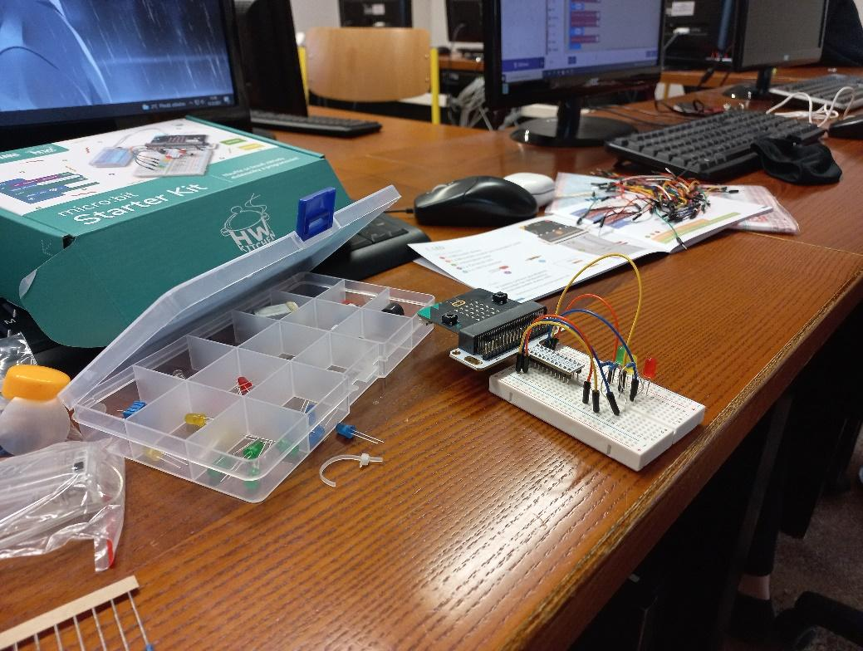

Online forms
During the preparatory phase, we learned to work with online Google forms, mainly with the functionality that allows us to evaluate user responses. It turned out to be very easy to create any form, after the correct solution of which, a new page will open for the user, on which it will be possible to write help for the next procedure in the escape book.
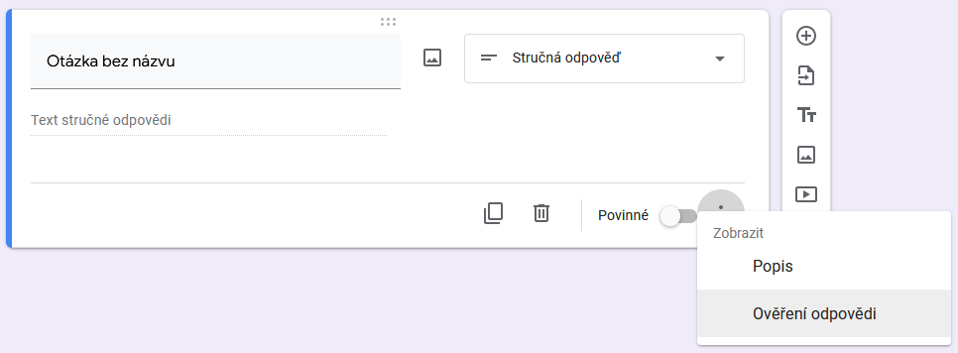

.

Escape game

Diagram
When we had all the hours spent testing ready-made escape rooms on different bases, testing different online environments for creating puzzles, and also had videos of physical experiments in progress, it was time to start the actual creation of our escape room. At this moment, experts from our group were profiled in the individual technical parts of creating an escape route, and the chosen team-leader coordinated everything under the guidance of the teachers.
One of the most important decisions was on which platform and how we would operate the entire escape hatch. We decided to use the Google ecosystem, specifically presentations and forms. Each room in our escape room thus has its own one-page online presentation, where the image is made up of a view of the given room and invisible links are made in it.
Such links can be easily created by inserting any shape, which is then set to a transparent colour and a hyperlink is assigned to it as needed. One such link is always slightly visible, it is the one that redirects the player to an online form, after solving it correctly, the player gets information about where to click in the room to get to the next room.;
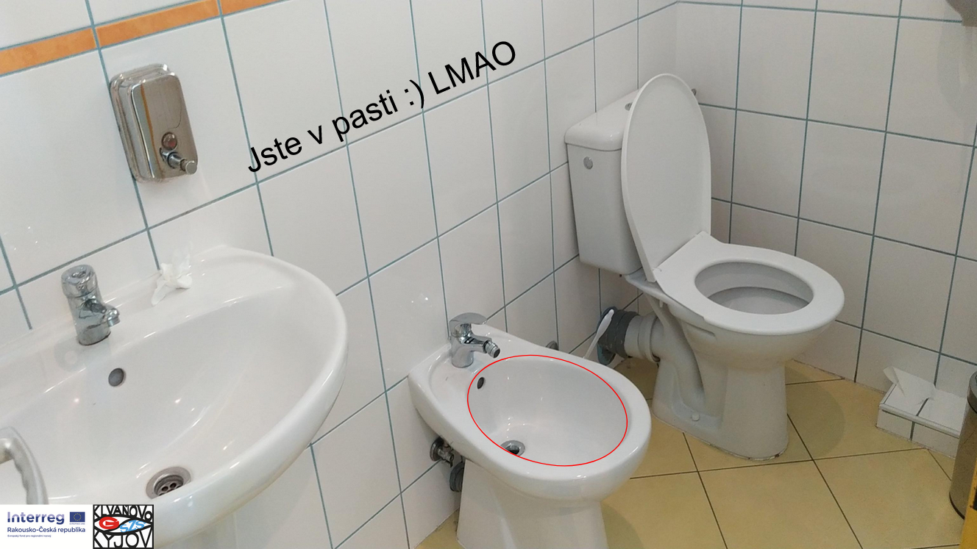
If the player randomly tried to click around the room, sooner or later he would probably hit the necessary point. In order to discourage the player from this "cheating", we added several links of the same type to each frame, but instead of moving the player forward, they lead him to the dead ends of our escape game and he has to go back.
So finally we planned the scope of our game, divided the rooms and tasks for them and got to work.

Cellar
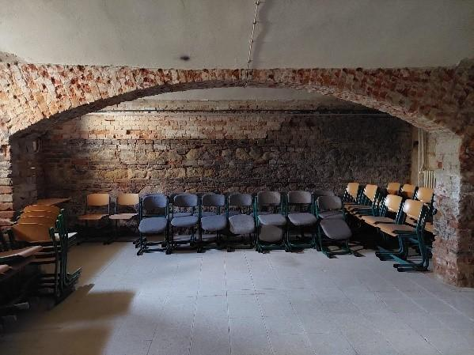
There is a basement inside the school that is not accessible to students or professors on normal occasions. We took the photos for our escape room with the help of a professor who has a universal key to the school catacombs.
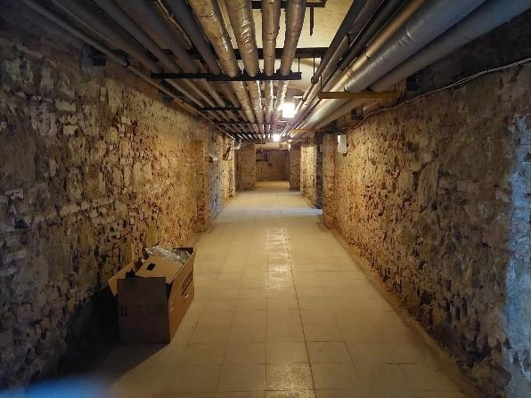
Our school cellar, which served as the beginning of our escape route, now also serves as a storage room for unnecessary benches and chairs, heating the school and storing the scooter of our beloved professor. All the photos were taken by our very willing classmates. The cellar is located in the foundations of the school building and is divided into two parts, one serves as a storage room and a boiler room (photos were taken here), we have no information about the other. The cellar is made of burnt bricks with arched ceilings. In the escape room, it serves as the first room, where there are traps, a door that will give you a puzzle (Mona Lisa) and a radiator head, which you will advance to the next room, which is a biological laboratory.

Biological laboratory
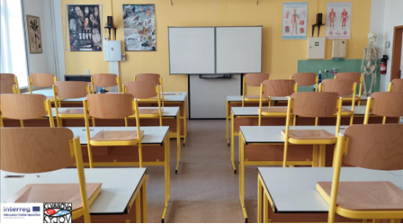
In the second part of the escape route, we find ourselves in the biology laboratory, which was reconstructed at the beginning of the 2021/2022 school year. We also have brand new MAX I LED/ACU microscopes, among the animal representatives a Mexican coral named René (according to our lady director) and two African snails.
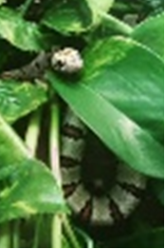

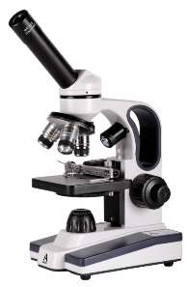
Thanks to the reconstruction, we were able to see and experience many interesting experiments, such as: dissection of a sheep's brain, eye or spinal cord, but also to look at the hay infusion with the already mentioned microscope or observe the cells of scale moss. In addition, we have a large number of stuffed animals and many visual aids for a better and more playful form of education. (heart, brain model...)
In the escape game, you have to find puzzles that make your heart come out.
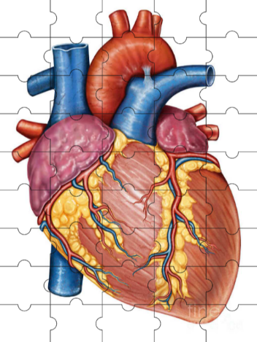
It is quite difficult, but we guarantee that it really can be put together. You can get to the next classroom, which is the Physics Laboratory, by clicking on the skeleton's knee.

Physics laboratory
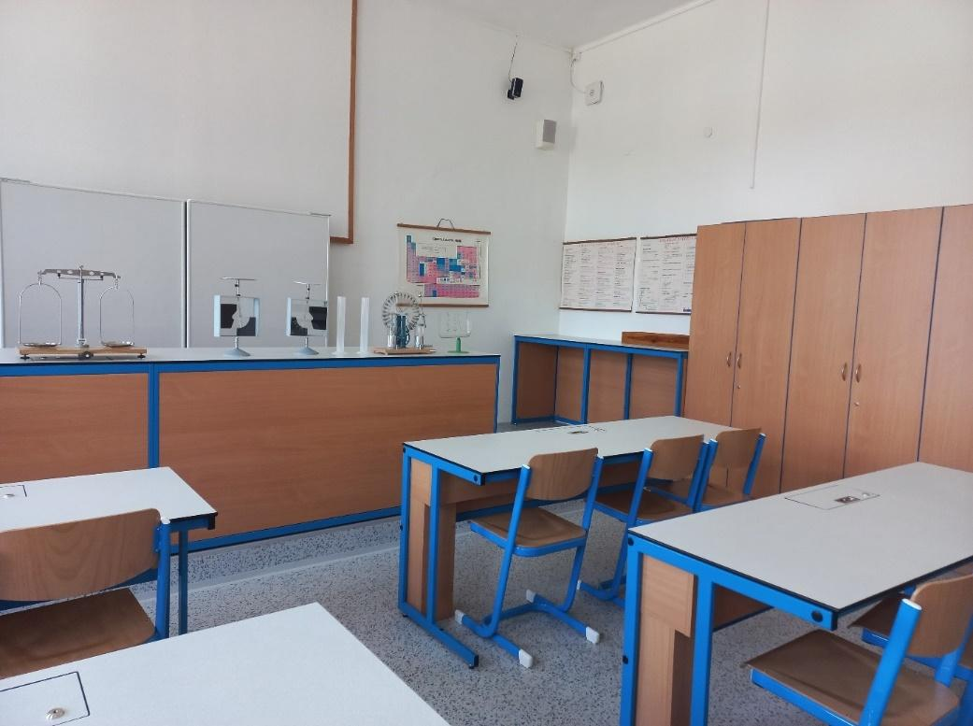
The physics laboratory is located on the second floor of the main building. The photo of the physics lab in our escape game may look a little dated, but make no mistake, our physics lab is not like that.
It is newly modernised. There are new blue benches arranged in two rows, new chairs, a new floor and new cupboards in which there are new tools for incompleteness. We did physics experiments with these tools this year. Because the experiments were very interesting, we had a lot of fun. We then filmed some of them. Sometimes we didn't get to film the experiment on the first try because it didn't work, or the classmates laughed so much that they had to leave the classroom, go outside and wait in the hallway for the experiment to be filmed. Sometimes it also happened that our camera ran out of power and we had to wait for the professor to put it on the charger and charge it. And when the camera was charged, we continued filming with smiles on our faces. We then successfully edited the recorded trials and used them to create questions in the forms. After successful completion, players will see a hint for further progress in the game.

History classroom
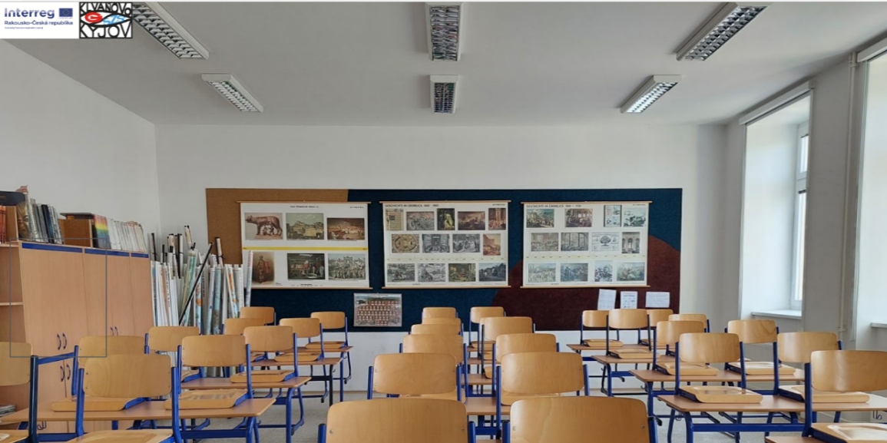
In our history classroom there are many historical maps, magazines and various textbooks.

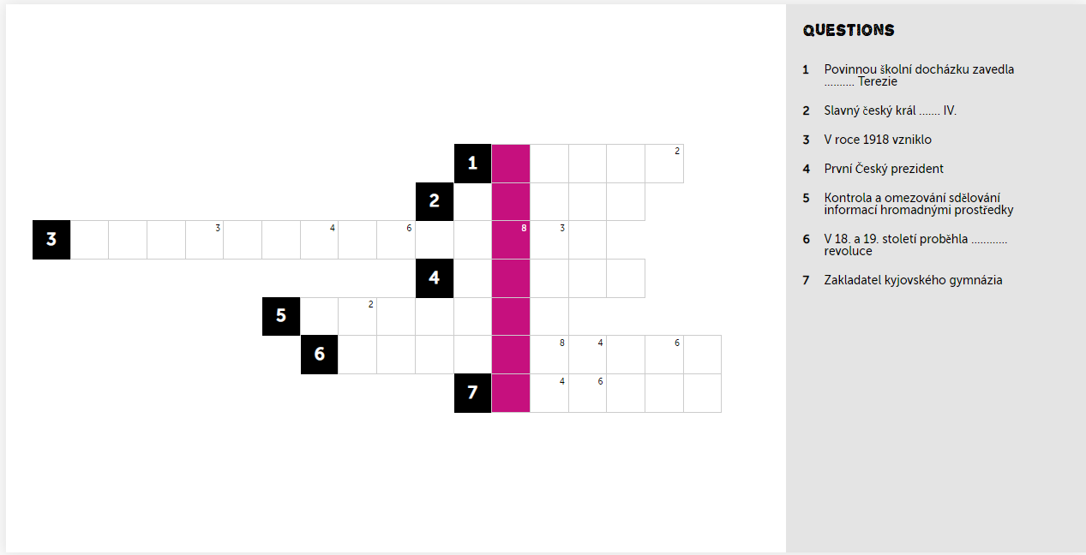
The first thing we had to do in order to be able to use it in our project was to take a picture of the classroom and insert the image into the presentation, from which the escape hatch was gradually created. Then we created a crossword puzzle with important historical terms from the history of the Czech Republic on https://puzzel.org/en/features/create-crossword and placed its link in this room. Furthermore, we put several traps here, as well as in the other classrooms, so that it is not so easy to get out of there. The next and last link in this room leads to the next part of the escape room, which is the geography classroom.

Geography classroom
It's the penultimate room of the escape room. It is located on the first floor of the adjacent building. This school year we are discussing the Czech Republic.
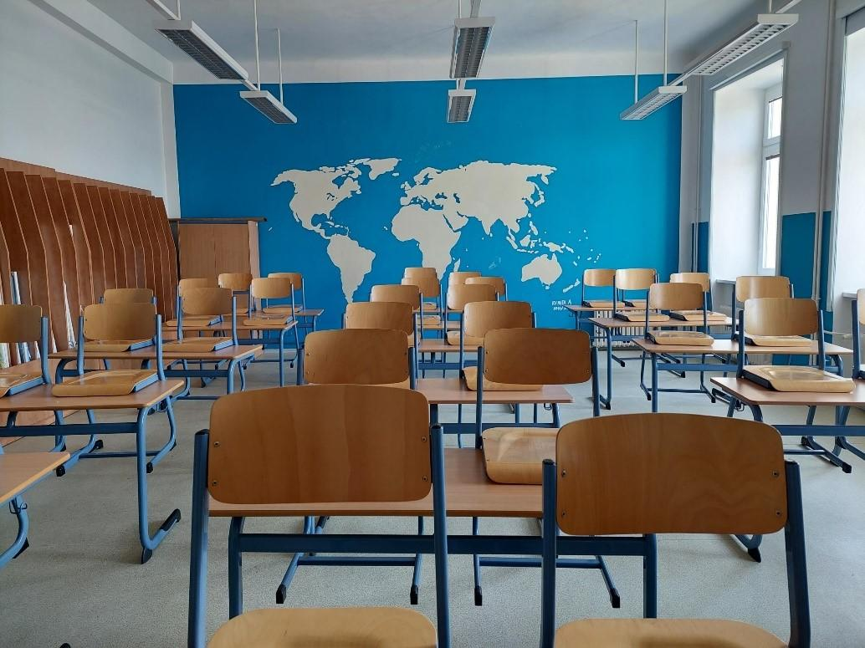
We have a lot of maps to use during the lesson, not only of the Czech Republic, but also of Europe and even maps of the whole world. The entire classroom is blue-white and in the back, on the blue wall, there is a map of the world stretching from ceiling to floor and from wall to wall. There is a white board and a screen with a projector in the front so that we can show interesting videos and documents so that we can have as much knowledge about geography as possible, and at the same time we enjoyed it as much as possible.

Chemistry classroom
In the second part of the escape game, you will get to the chemistry classroom, where you will meet many interesting tasks and maybe even learn something new.
The chemistry classroom is a place for students to apply their knowledge and skills in chemistry. It is located on the second floor of the main building. In this classroom we carry out various interesting and unusual experiments.
Chemistry Olympiad winners and lovers of the secrets of chemistry are also born here. Both the teaching pedagogue and the inquisitive student feel comfortable in our school chemistry classroom.
The basic concept of our chemistry educational classroom is made up of a set of teacher and student facilities. The student workplace is made up of free-standing double benches, and we also have a central panel. Additional accessories: audio-visual equipment, interactive media, software, measuring devices, electrical sources and a demonstration system. Although the classroom is not one of the newly renovated classrooms, it still provides us with a pleasant background for learning this subject.

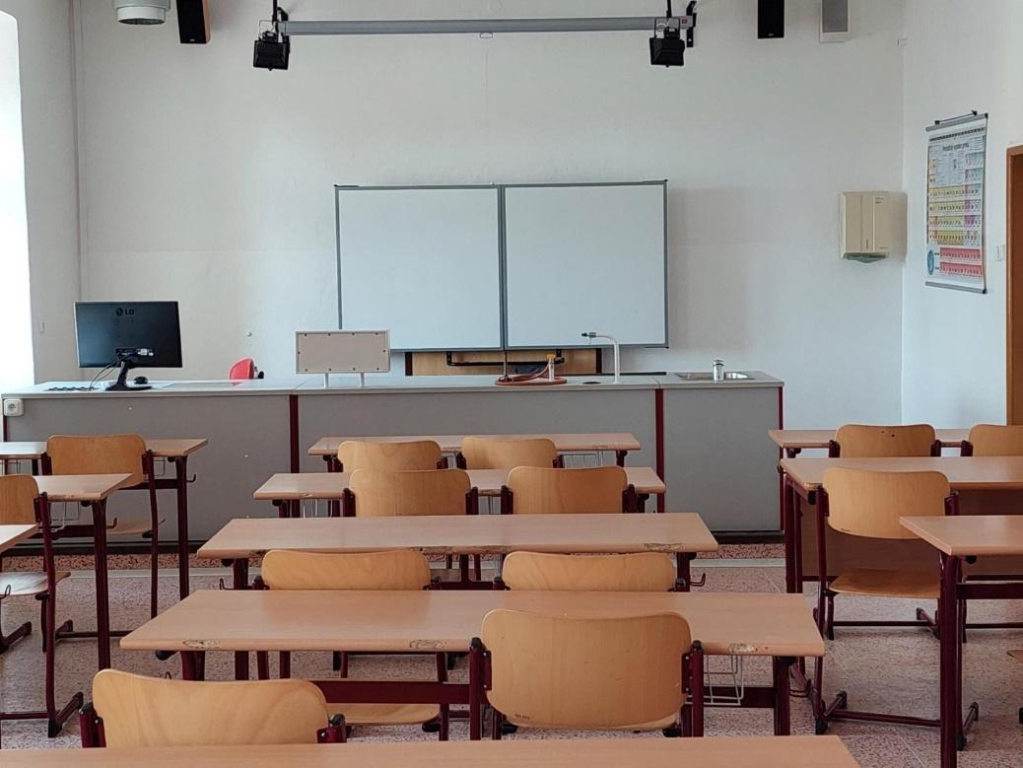
In the escape game, you can use this classroom to get out of Klvaň's gymnasium. All you h
ve to do is fill out a short test of chemical aids that we often use in the classroom.

The End
The last picture of our escape show is a view of our beautiful school, enhanced by several graphic effects. In order to connect the game with a possible promotion, there is also a link to our website on this image.
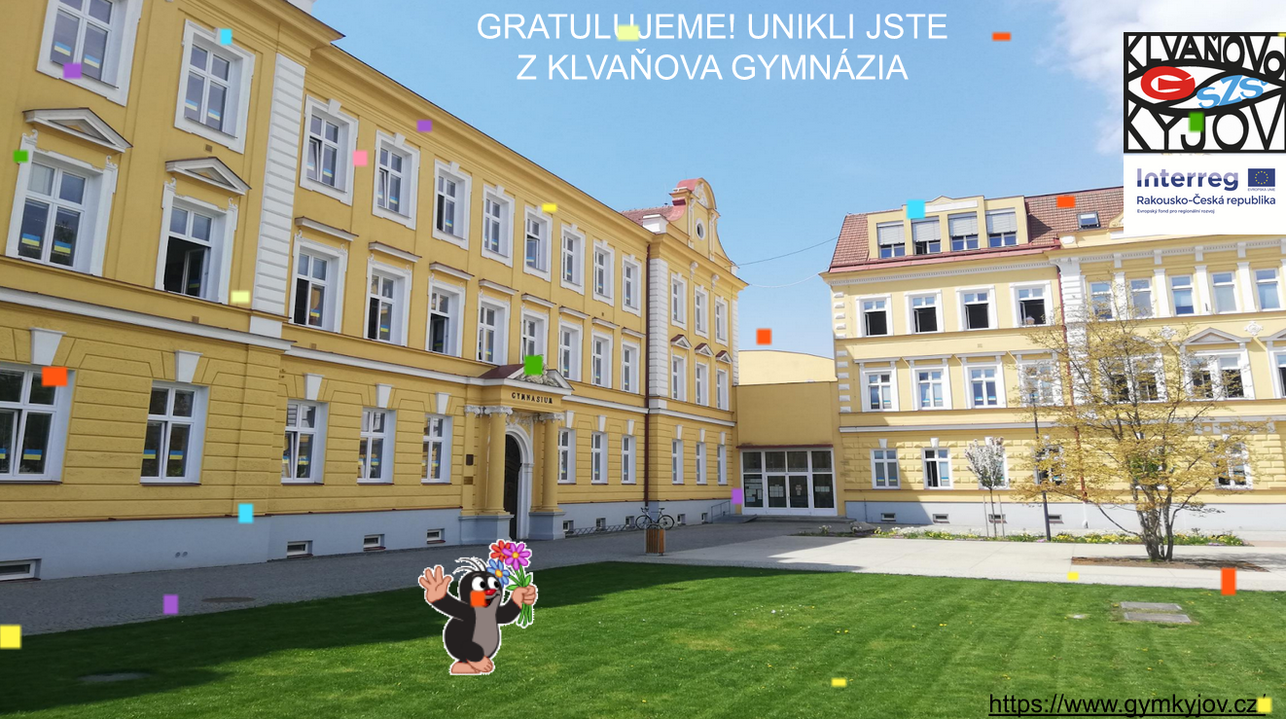

Operation of escape hatch

Making the escape route available to the public
In order to make the escape game accessible to the public, we had to create a link, but since the created link was too long, we then shortened it using the URL Shortening page. We have also placed the link on our school's website. As a next step, we created a QR code (Quick Response). We created the code using the QR code generator page. We placed the code and the link in our presentation that we presented in Brno. We also printed a QR code so that those interested could play the escape game right away.
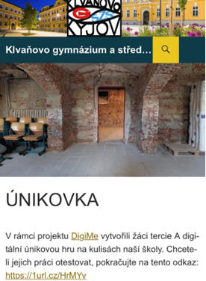
Not only many students from our school tried the escape game, but also parents and students from other schools. We were very pleased with the positive evaluation we received from them.
We are happy that people are playing our escape game and that they like our work.
Links to the pages we used to shorten the link and create a QR code:
URL shortening - https://1url.cz/

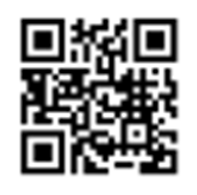
QR code generator – https://www.qr-code-generator.com/

Limiting the number of solutions
A few weeks after publishing our escape game, there was a big twist. The puzzle could not be solved due to exhausting the page opening limit in the first round, which meant that the quest could not be continued. It was clear to us that over time this problem would also occur with other tasks.
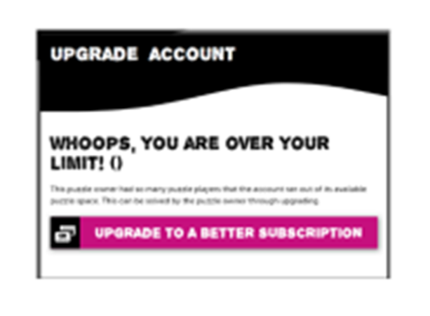
There was one thing we could do to fix the problem, and that was to find a whole new page to recreate the quests to put back into the escape room. But such a site is very difficult to find, because the sites are either paid for or do not meet our requirements.
In the end, the problem solved itself for the time being. After a week when the link did not work, or led to a page with information about the exhausted limit, this limit was probably renewed and now everything fit works as it should. It can therefore be expected that this may occur with great interest, but we consider it a sufficient solution for normal operation. The aforementioned exhaustion of the limit occurred during a massive distribution campaign, which we do not plan to repeat in the future.

Conclusion
The goals of the project were fulfilled, the pupils tried out many new skills as part of acquiring digital competences and enjoyed the whole work. The whole project also contributed to the bonding of the team. The icing on the cake was a great fourth place among the other participating schools.
If we were to do the project again, we would probably try to take different paths in some parts. In any case, we have gathered valuable experience and we will benefit from it at school in the coming years in the teaching of informatics, but also in other subjects in which digital education is increasingly integrated.

